Rempstone Village Hall
Tea & Games Afternoon
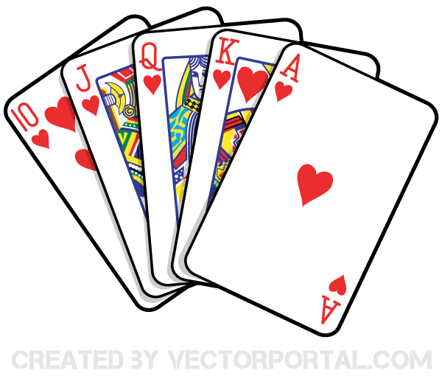
Join us to play your favourite board games or just enjoy tea and cake on:
Thursday January 11, 2 - 4pm
Thursday February 8, 2- 4pm
Thursday March 8, 2 - 4pm
Thursday April 12, 2 - 4pm
Thursday May 10, 2 - 4pm
Thursday June 7, 2 - 4pm

Rempstone Village Hall Committee
Registered Charity no: 1145204

