Pledging Support for a Community Fibre Partnership

A Community Fibre Partnership is underway in your area to deliver a gigabit-capable, full-fibre connection to residents and businesses that are without good quality broadband. The good news is that the cost to deliver the network will be covered by the funding available from the Government’s ‘Gigabit Broadband Voucher Scheme’. All that is required is residents and businesses within the group scheme pledge their support to the scheme. When enough members of the community scheme pledged their support to the build – Openreach will then deliver the network.
As the cost of the network delivery will be covered by the available subsidy from central government members of the group scheme won’t be asked to financially contribute towards it. All that is required is for residents and businesses to pledge their support for the scheme via the community website. When the network is delivered residents and businesses will be able to take out a full-fibre broadband service from a number of communications providers that utilise the Openreach network.
A full-fibre, gigabit-capable network (sometimes referred to as FTTP) is the most up-to-date broadband provision available in the UK. A full-fibre network means it’s fibre optic cable all the way from the exchange to your property, which means you’re completely omitting the copper network traditionally used for broadband delivery, along with the downsides that are associated with the copper network (poor reliability, lower speeds available, technological limitations). The cost of a full-fibre broadband service is comparable to broadband services provided over the copper network. As a full-fibre broadband service does not require the rental of a phone line, some residents and businesses could even lower their monthly subscription, by moving to a full-fibre service.
The opportunity that is available to residents and businesses here may not present itself again as the voucher scheme is set to draw to a close on the 31st of March, 2021. It is imperative that if this group scheme is to be delivered the community pledge their support and assist with engagement to deliver the scheme. If this opportunity is not taken there can be no guarantee when a broadband upgrade for the area in question is delivered.

How to pledge your support for the Community Fibre Partnership:
- Head to https://www.openreach.com/connectmycommunity

- Scroll down the page to the question regarding voucher qualification:
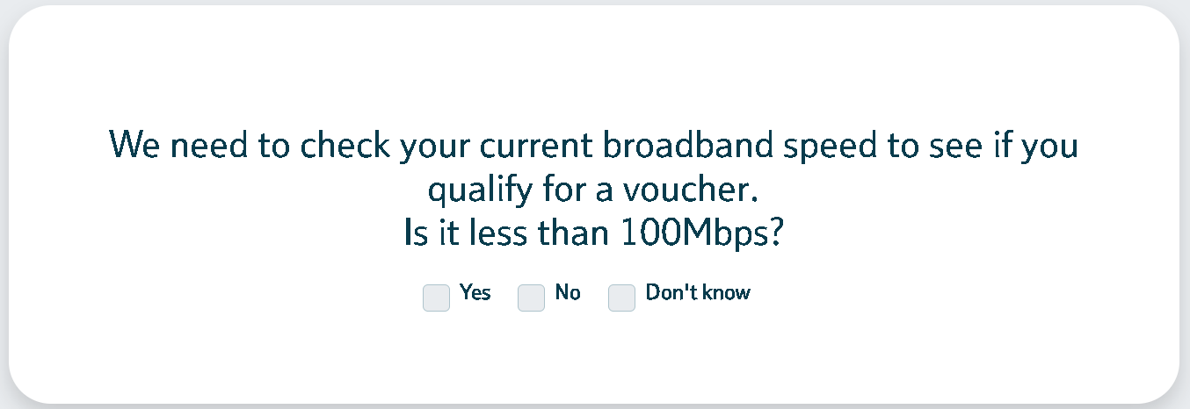
Select ‘yes’

- On the next dialog box you’ll be asked to input your postcode to check area’s eligibility. This is where residents and businesses that are listed on the group scheme enter their postcode. You may be asked to complete a captcha.
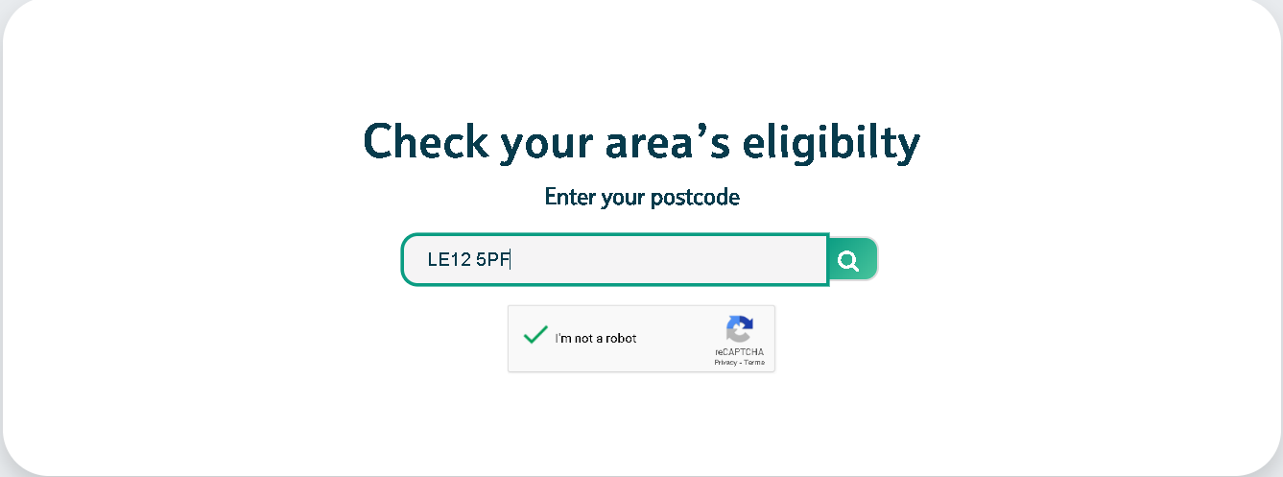

- You’ll then be taken to a page which displays your Community Fibre Partnership project page
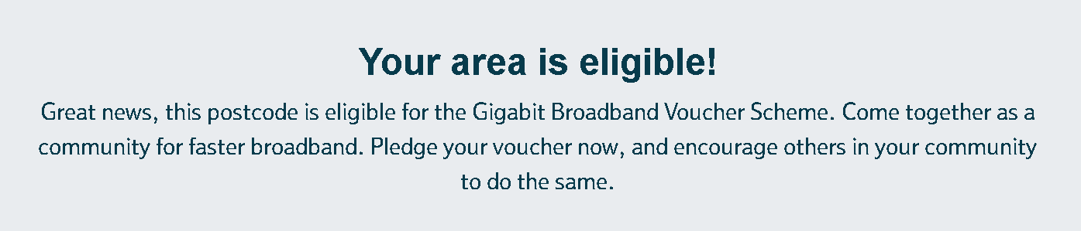

- Scroll down and you’ll see the current pledge’s associated with the Community Fibre Partnership project
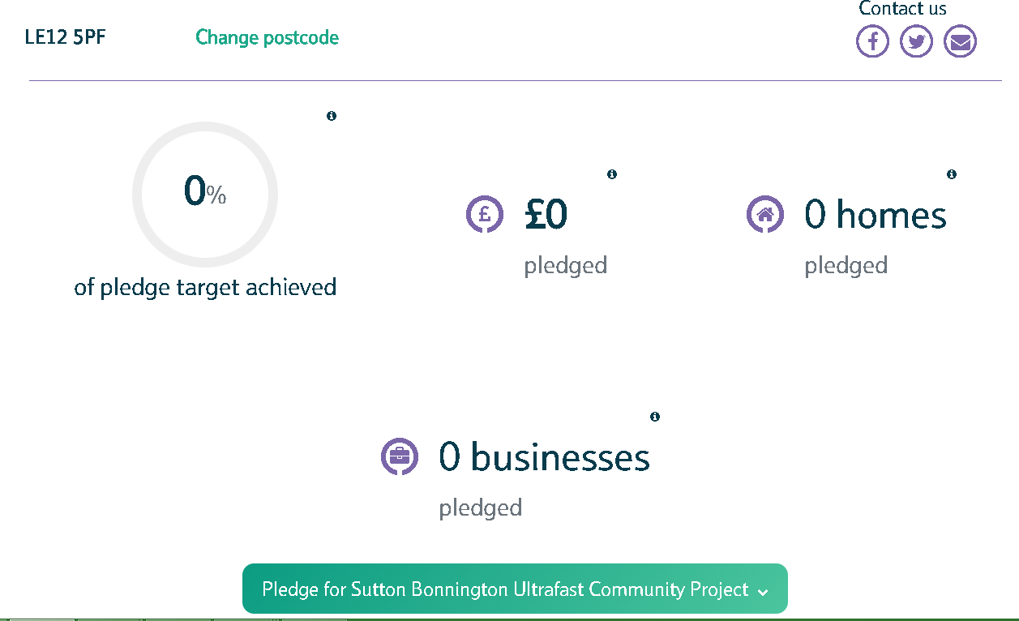

- When you click on the ‘pledge’ option at the bottom of the page, you’ll be able to register your details, and pledge your support to the scheme.
When enough support to the scheme has been pledged Openreach will then draw up a contract for delivery and have 12 months to deliver the network.

The Better Broadband for Nottinghamshire team is here to help group schemes in getting the support they need to deliver them, but we need your help and help from the community to deliver this scheme.
If there are any questions regarding the process please do not hesitate to get in touch with the team at enquiries.broadband@nottscc.gov.uk

