Rempstone Parish Council and Village Hall Committee
Coronavirus Working Party – Newsletter 21
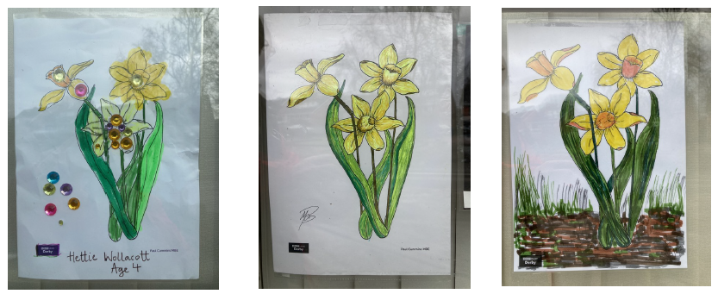
Unlocking the Village. We’ve all seen the plan for re-opening the country after the pandemic. It looks as if we will be able to hold the planned Village Fete on Sunday 27th June, and the Village Show on Sunday 12th September. Jane is taking advice on how soon we can open the Village Hall for Coffee Mornings and other events.

Fibre Broadband. The Parish Council are talking to Openreach about making fibre broadband available to all houses in the village. Fibre broadband is much faster and more reliable than the current service. Installation costs will be covered by the Government’s Rural Broadband Scheme for those households which register interest by 31st March. If you haven’t already done so then you can register at: Connect my community (openreach.com)

Easter raffle tickets will be available next week. The raffle will be drawn at the end of the March.

Food Banks. Claire continues to take your donations to Food Banks in Loughborough and Nottingham. She is also collecting clothes and food for a Baby Bank. More on this next week.

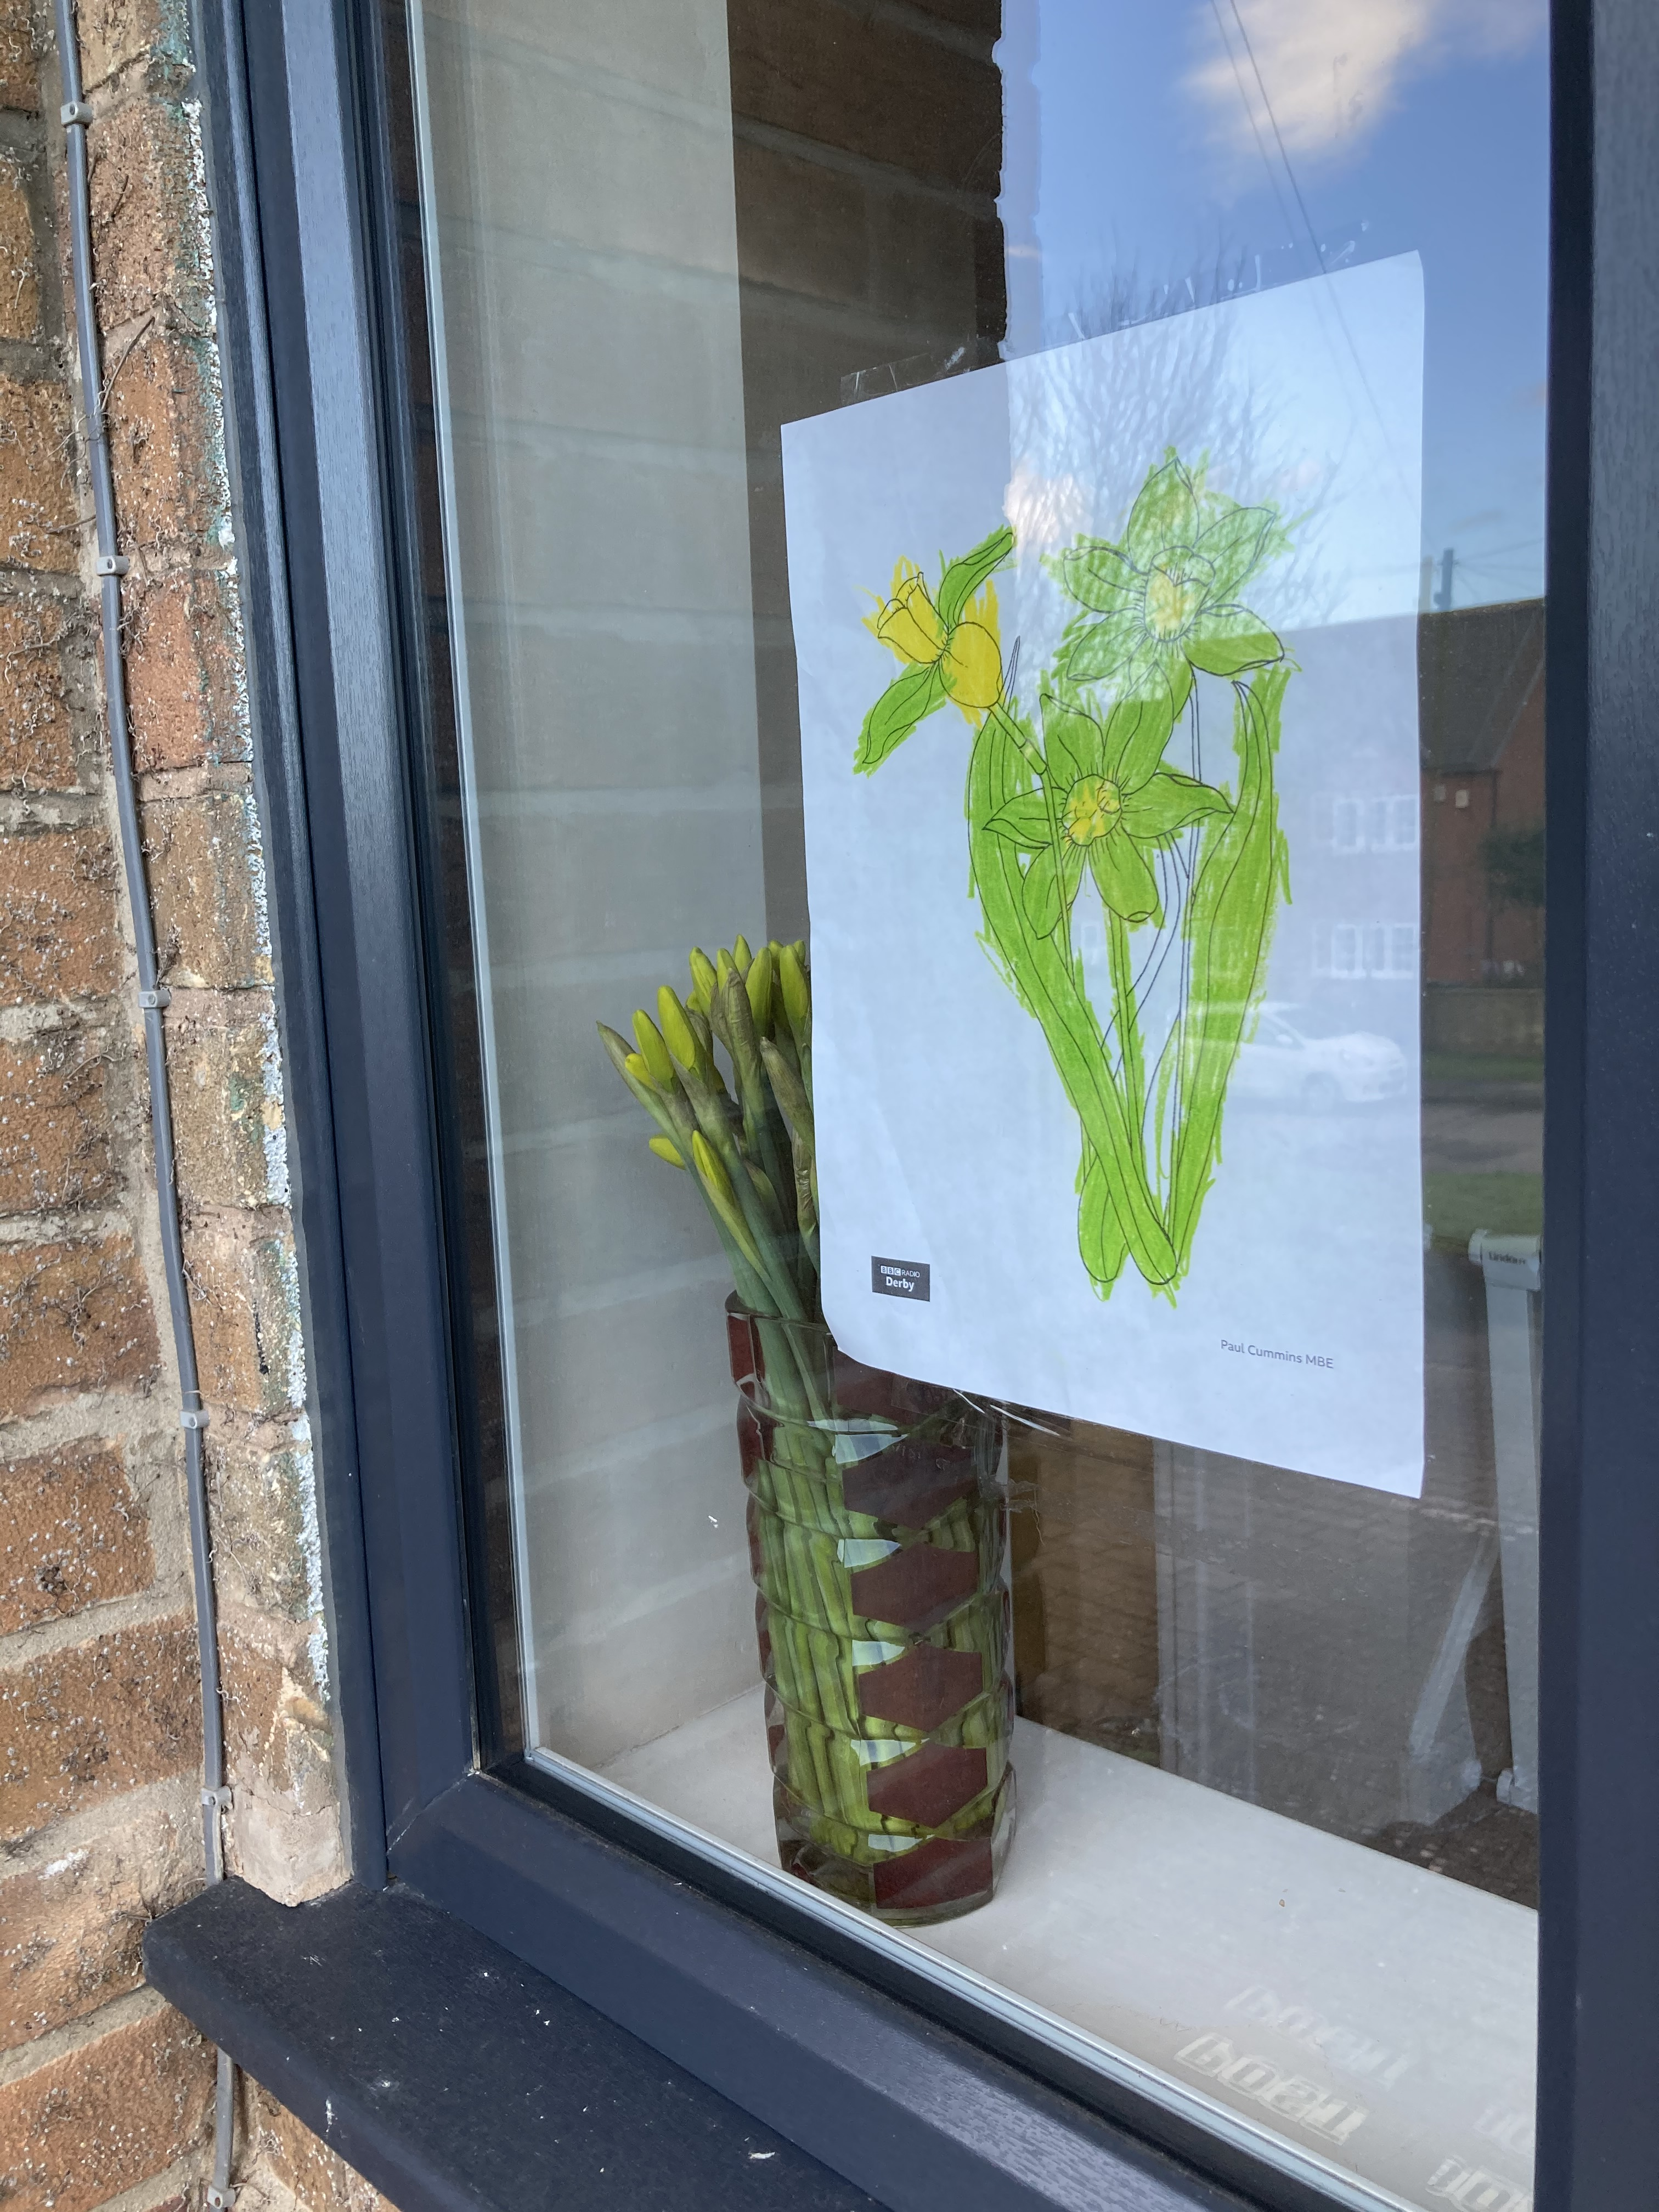
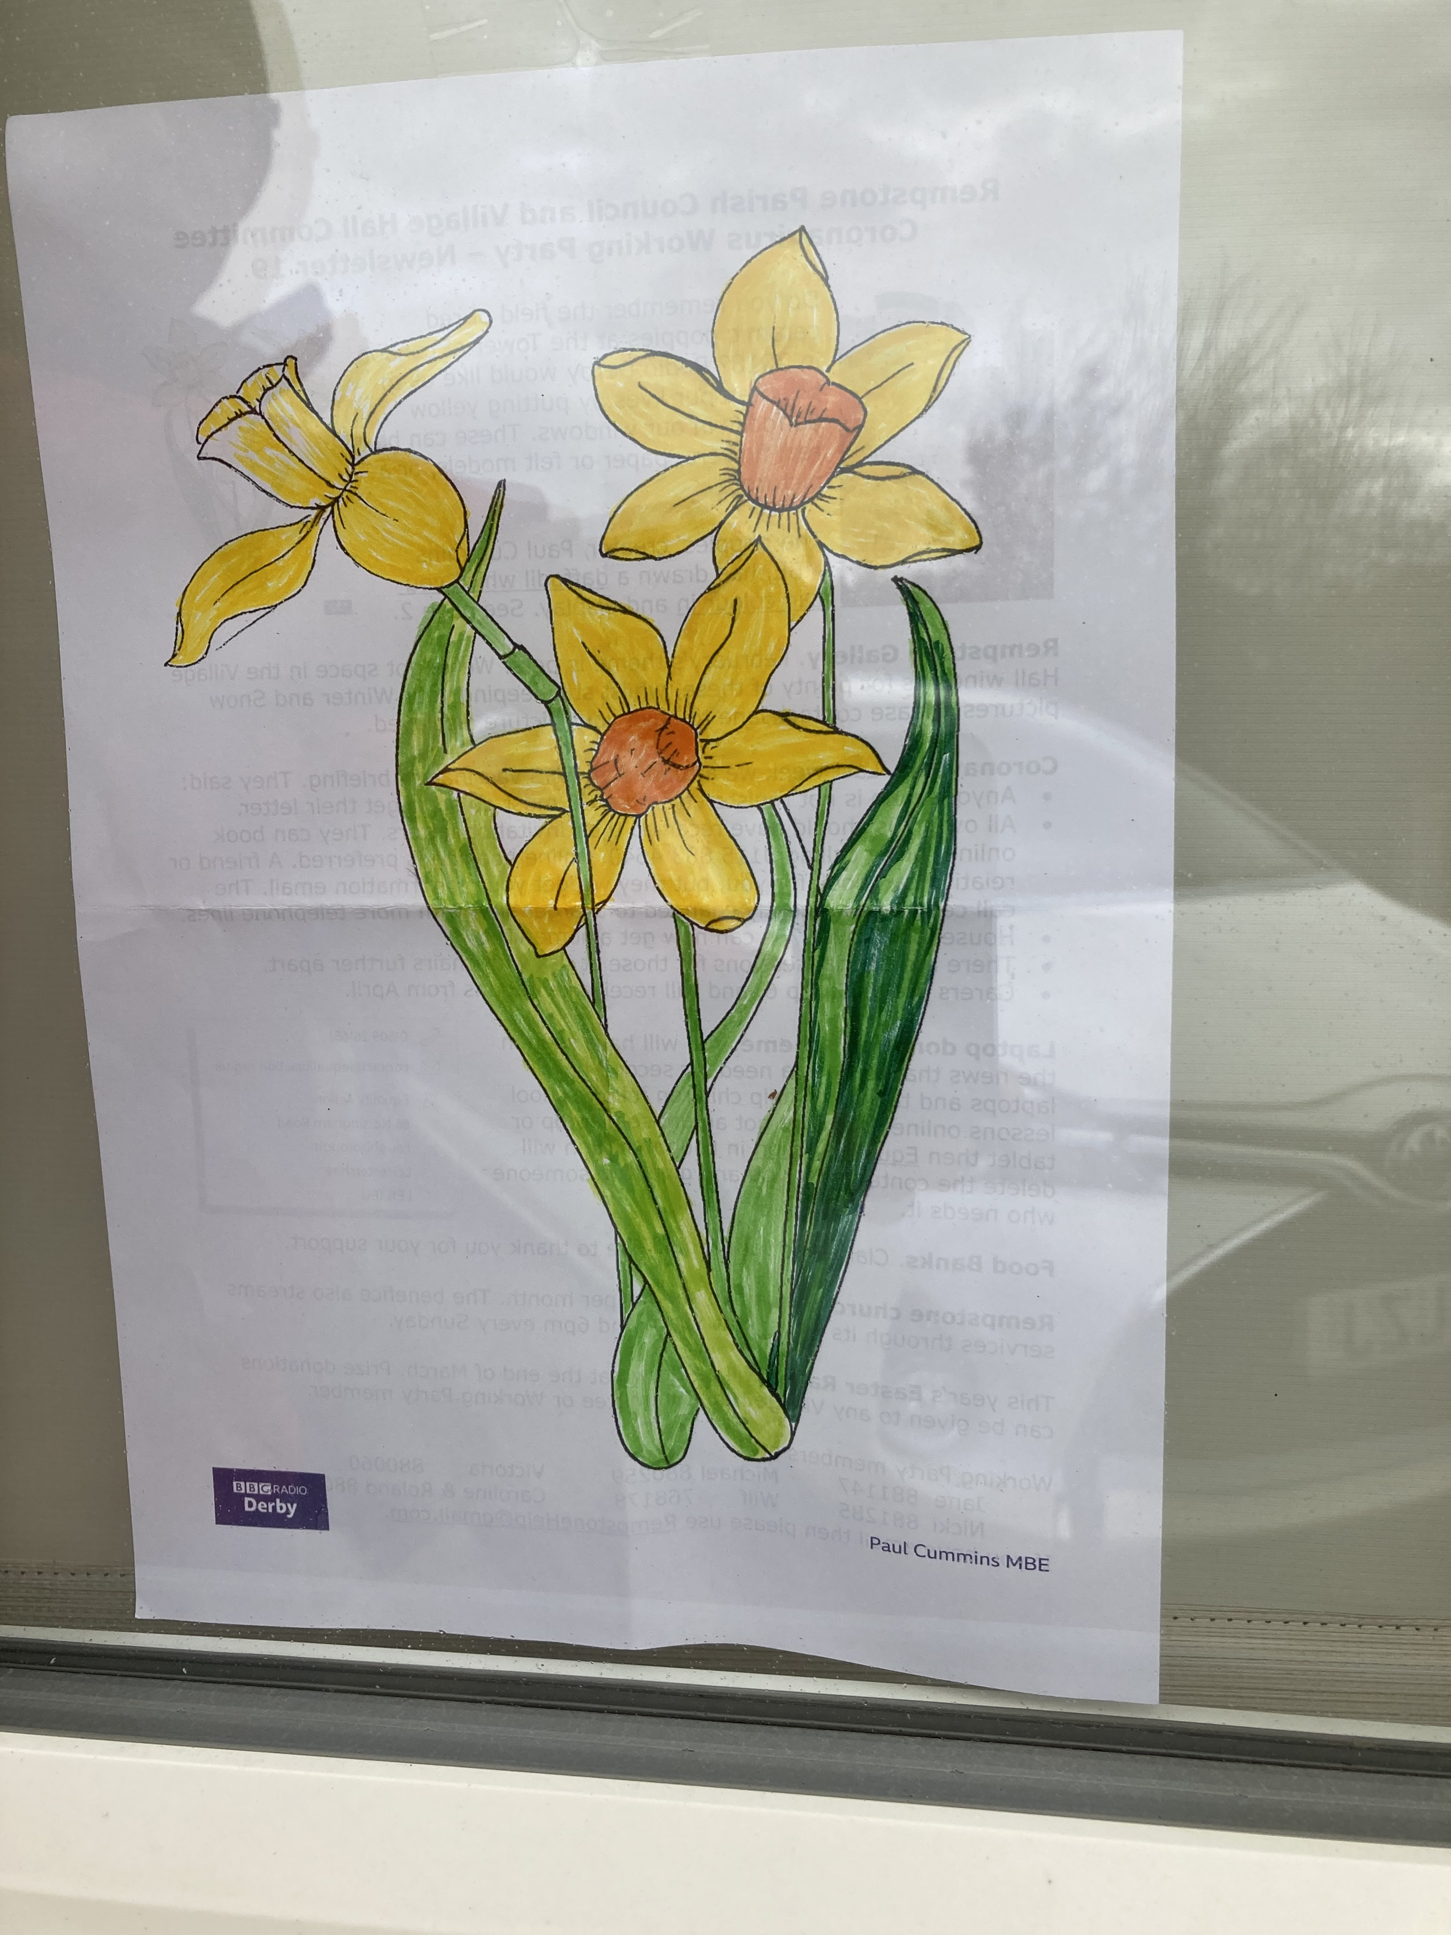
Working Party members are:

Jane 881147
Michael 880259 Victoria 880060
Nicki 881285
Wilf 768178 Caroline & Roland 880257
or email us at RempstoneHelp@gmail.com.

