Rempstone Parish Council and Village Hall Committee
Coronavirus Working Party – Newsletter 19
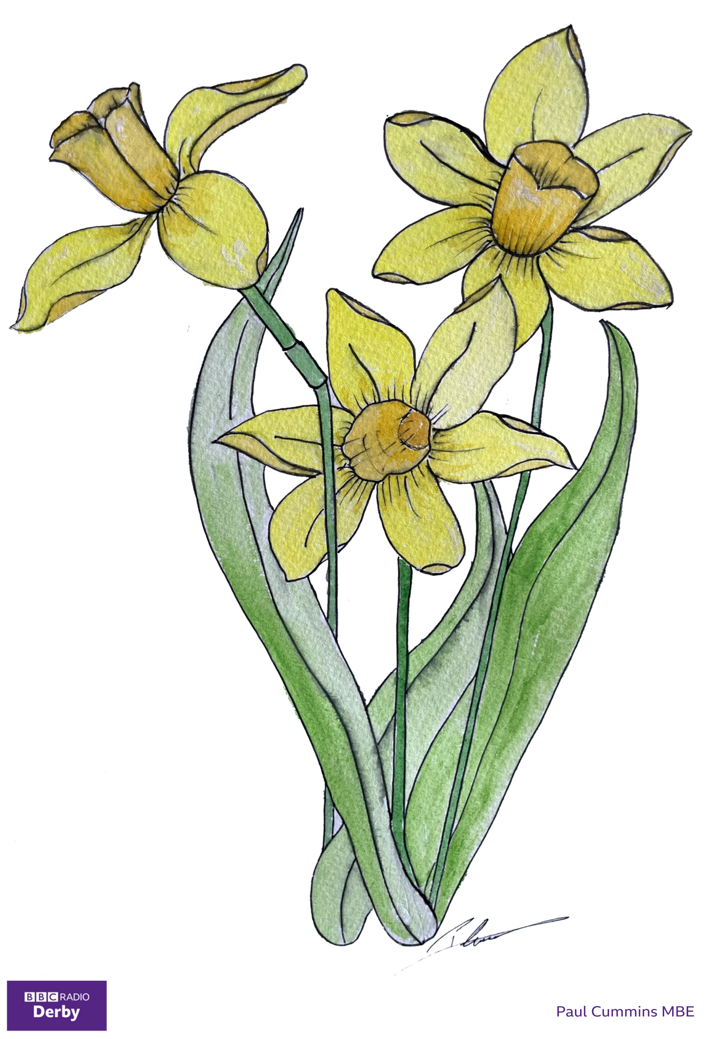

Do you remember the field of red ceramic poppies at the Tower of London in 2018? Radio Derby would like us to brighten our lives by putting yellow daffodils in our windows. These can be real flowers, paper or felt models, or a picture.

The poppies’ creator, Paul Cummins MBE, has drawn a daffodil which you can colour in and display. See page 2.

Rempstone Gallery. February’s theme is pets. We’ve got space in the Village Hall windows for plenty of these, whilst still keeping your Winter and Snow pictures. Please contact Jane to have your picture displayed.

Coronavirus. Last week we attended an NHS vaccination briefing. They said:
- Anyone who is not registered with a GP must do so to get their letter.
- All over 70s should have received their invitation letters. They can book online, or by calling 0115 883 4640. Online booking is preferred. A friend or relative can book for you, but they will get your confirmation email. The call centre has recently changed to a larger site, with more telephone lines.
- Housebound over 70s can now get a home visit.
- There are special sessions for those at risk with chairs further apart.
- Carers are in Group 6, and will receive invitations from April.

Laptop donation scheme. You will have seen in the news that there is a need for second-hand laptops and tablets to help children follow school lessons online. If you’ve got an unused laptop or tablet then Equality Action in Loughborough will delete the contents for you and give it to someone who needs it.

Food Banks. Claire and Jane would like to thank you for your support.

Rempstone church holds two service per month. The benefice also streams services through its website at 10am and 6pm every Sunday.

This year’s Easter Raffle will be drawn at the end of March. Prize donations can be given to any Village Hall Committee or Working Party member.

Working Party members are:
Jane 881147 Michael 880259 Victoria 880060
Nicki 881285 Wilf 768178 Caroline & Roland 880257
If you have email then please use RempstoneHelp@gmail.com.


